Paul Kafka
3/20/12
Homework 5

Design an automated functional simulation (Type III Testbench) for the carry-ripple adder of example 6.4 in our textbook. Use the same stimuli employed in the graphical simulation of figure 6.7 in our textbook. Complete Exercise 10.13 of our textbook. Use Hexadecimal to display the waveform results.

Part 1:
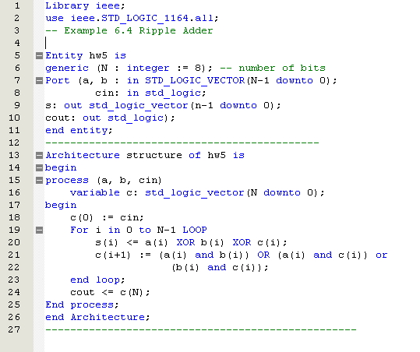
Ripple Adder
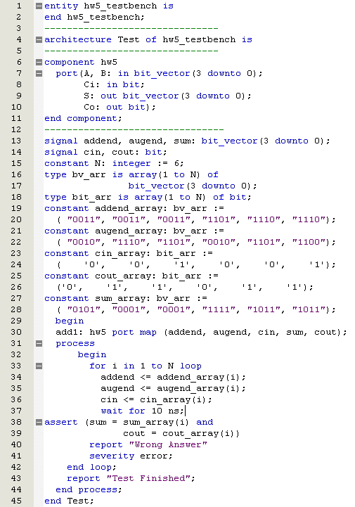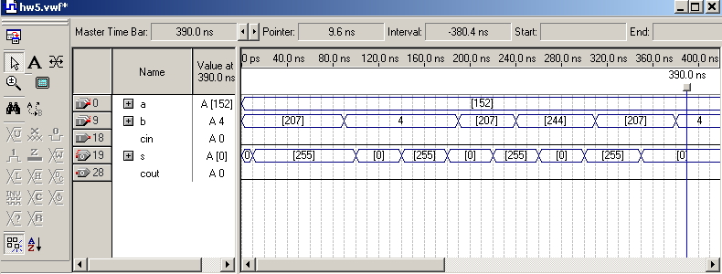
Type 3 TestBench
Stimuli Simulation

Part 2:
10.13
Develop a type1 testbench to test the 6.4 adder (like in example 10.4). Use the same stimuli employed in the graphical simulation of figure 6.7. Use Hex to display waveform.
Type 1 Testbench
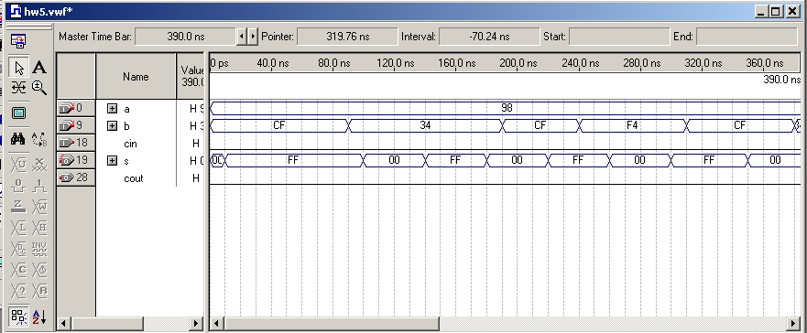
Hex Output

